A

Technical Report

on

**ROOM AIR PRIUFIER**

*Submitted to CMR Institute of Technology in the partial fulfillment of the requirement of*

**Social Innovation Lab**

Of

**II B.Tech I- Semester**

in

**ECE DEPARTMENT**

Submitted by

**M.VISHAL (20R01A04F3)**

**P.SAHITH (20R01A04G8)**

**M.SANJAIAH**  **(20R01A04F2) MD.SOHEL (20R01A04G0)**

**K.RITHWIK (21A05A0416)**

***Under the esteemed guidance of***

*Ms.Y.Sushma*

*Assistant Professor*



**CMR INSTITUTE OF TECHNOLOGY**

**(UGC-AUTONOMOUS)**

(Approved by AICTE, Permanently Affiliated to JNTU Hyderabad, Accredited by NBA, Accredited by NAAC with A Grade)

Kandlakoya (V), Medchal Road, Hyderabad  501 401

**2021-2022**

***Department of ECE***

**Certificate**

This is to certify that the technical report entitled “***ROOM AIR PRUFIER***” is the bonafide work done and submitted by

**M.VISHAL**   **(20R01A04F3)**

**P.SAHITH**  **(20R01A04G8)**

**M.SANJAIAH**  **(20R01A04F2) MD.SOHEL (20R01A04G0)**

**K.RITHWIK (21R05A0416)**

towards the partial fulfillment of the requirement of Social Innovation (SIL) Laboratory of **II B. Tech I-Semester** in **ECE** is a record of bonafide work carried out by them during the period **Sep 2021 to Jan 2022.**

**Guide Co- Ordinator Head of Department**

**Ms.Y. Sushma Mr. S.Gopala krishna Dr .K.Niranjan Reddy**

**(Assistant professor) (Assistant professor) ECE Department Civil Department ECE Department**

**INDEX**

**Topics Page No**

**CHAPTER-I INTRODUCTION 1-2**

**CHAPTER -II Empathize 3**

**CHAPTER -III Define**  **4-5**

**CHAPTER -IV Ideate 6-7**

**CHAPTER -V Prototype 8-15**

**CHAPTER -VI Test 16**

**CHAPTER -VII References 17**

1. **INTRODUCTION**

* **WHAT IS SOCIAL INNOVATION?**

The term ‘social innovation ’once rarely heard is ,now often used to describe a whole variety of things that fall into general categories of being both new and good.It’s understandable that the phrase has become popular-we get excited and hopeful when it seems possible for real change to happen in the world.

Social innovation refers to the Design and implementation of new solutions that imply conceptual ,process ,product or organisational change which ultimately aim to improve the welfare and wellbeing of individual communities

Social innovation is not a new concept and should not be considered similar to other definitions, such as social entrepreneurship, creativity or invention, improvement or change. 'As with innovation in technology or business, social innovation is distinct from ‘improvement’ or ‘change’ and from ‘creativity’ and ‘invention’. These last two are both crucial to innovation but overlook the important stages of implementation and diffusion which make new ideas useful.

* **What is design thinking process?**

Design Thinking is a design methodology that provides a solution-based approach to solving problems. It’s extremely useful in tackling complex problems that are ill-defined or unknown, by understanding the human needs involved, by re-framing the problem in human-centric ways, by creating many ideas in brainstorming sessions, and by adopting a hands-on approach in prototyping and testing. Understanding these five stages of Design Thinking will empower anyone to apply the Design Thinking methods in order to solve complex problems that occur around us — in our companies, in our countries, and even on the scale of our planet.

Design thinking originally came about as a way of teaching engineers how to approach problems creatively, like designers do. One of the first people to write about design thinking was John E. Arnold, professor of mechanical engineering at Stanford University.

**1**

**The five stages of design thinking:**

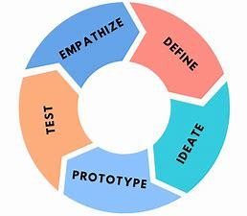

1. Empathize-The Design Thinking process starts with empathy. In order to create desirable products and services, you need to understand who your users are and what they need.
2. Define- In the second stage of the Design Thinking process, you’ll define the user problem that you want to solve.
3. Ideate.-The third stage in the Design Thinking process consists of ideation or generating ideas. ...
4. Prototype- In the fourth stage of the Design Thinking process, you’ll turn your ideas from stage three into prototypes.
5. Test -The fifth step in the Design Thinking process is dedicated to testing: putting your prototypes in front of real users and seeing how they get on.

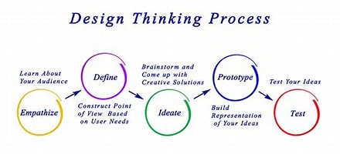

**2**

1. **Empathize**

The first stage of the Design Thinking process is to gain an empathic understanding of the problem you are trying to solve. This involves consulting experts to find out more about the area of concern through observing, engaging and empathizing with people to understand their experiences and motivations, as well as immersing yourself in the physical environment so you can gain a deeper personal understanding of the issues

involved. Empathy is crucial to a human-centered design process such as Design Thinking, and empathy allows design thinkers to set aside their own assumptions about the world in order to gain insight into users and their needs.

We have collected information from various sources like conducting surveys among the people about their problems as they are facing right now and interviewing people, reading novels from various books ,collecting information from the internet.

As our team has conducted a survey among the people at the current problems they are facing we have got many problems to be listed .In those information we have found many valid problems as they are facing in the day to day life and the collected information have been segregated accordingly.

We have shortlisted few problems which are being affected by the most people in the society .

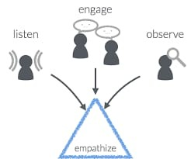

So , have chosen one of the problem that is the air pollution is the major problem from the shortlisted problems that many people are facing and its causes wealth lose , human lose and many more .

**3**

**Survey on Air pollution:**

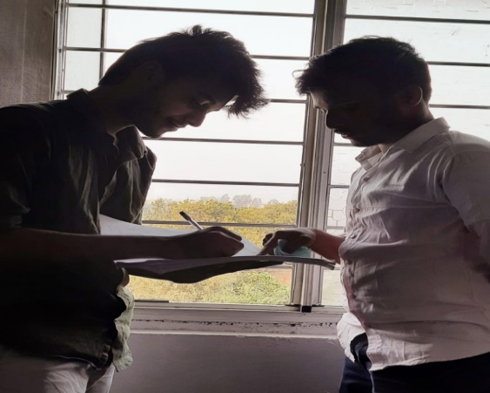

**Team member 1:**Are you,facing any problem with environment?

**Person1:**yes,Air pollution

**Team member 1**:What do you think about air pollution?

**person 1:**emission of harmful chemicals into the air leads to air polution.

**Team member 1:**Did air pollution affect your life?

**person1:** air pollution is resposible for more deaths than many other risks.

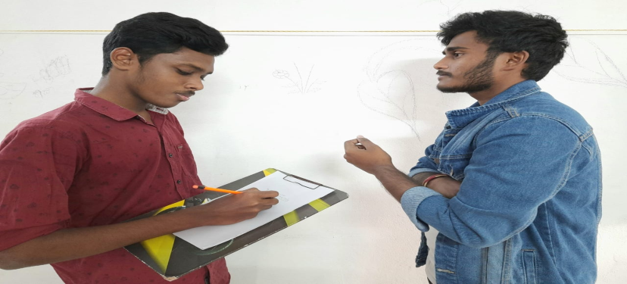

**Team member 2**:How much you know about air pollution?

**person 2**:Burning fosil fuels for power,transport and industry is a major contributer to air pollution

**Team member 2:** Did air pollution affect your health?

**person 2:**Air pollution increases the risk of respiratory and heart diseases.

**Team member 2**:what can help you to prevent pollution?

**person 2:**by using air purifier.we can prevent air pollution,But is expensive.

**3.Define**

In this define stage, we have defined the problem statement accordingly to our problem. According to the scenario as we have collected information in the empathy stage we have defined the problem statement as “ROOM AIR PRUIFIER”

**3.1. Problem Statement**

Long-term exposure to **polluted air** can have permanent health effects such as: Accelerated aging of the lungs. Loss of lung capacity and decreased lung function. Development of diseases such as asthma, bronchitis, emphysema, and possibly cancer.

There are many methods to control air pollution like planting trees, using renewable resources and air purifiers. But also we can see there is reduction in no air pollution ,due to this many people are not able to breathe properly even in their houses ,and facing many health problems .

**3.2 Objective :-**

* The main motto of our project is that to reduce the pollutants in air and reduce the diseases spreading due to air pollutants.
* To combine advanced detection technologies to produce an air quality sensing system with advanced capabilities to provide low cost comprehensive monitoring.

· To display the sensed data in user friendly format in LCD display panel.

**3.3 ADVANTAGES AND DISADVANTAGES OF EXISTING SOLUTIONS**

**1. Growing plants in houses:-**

**ADVANTAGES:-**

* They give fresh air and remove toxins from the air about 87% .
* As part of the photosynthetic and respiratory processes, plants release moisture vapor, which increases humidity of the air around them**.**
* It creates a very pleasant environment and it helps to breathe easily.

**DISADVANTAGES:-**

* Maintenance is difficult .plants need a lot of space and it occupies much space in households.
* Water should be supplied regularly in a proper way.
* In summer season the plants may die due to sun and may not much effective at those time.
* It is expensive and requires lot of time for maintenance.

**2.AIR PURIFIERS :-**

**ADVANTAGES:-**

* Eliminates harmful chemicals from indoor environment.
* Neutralizes unpleasant Odour.
* Reduces the chance of airborne diseases

**DISADVANTAGES:-**

* Heavy maintenance .
* ozone emissions .
* Highly expensive (everybody cant afford it ).
* More electricity consumption .

**4.Ideate**

In this design thinking process we have ideate as the next stage and we have come up with a solution according to the above problem statement as we have mentioned.

Basically our model can be divided into two parts one is the air purifier part and other is the monitoring of air pollution device.

As we have gone through the need statement with literature review .so that we can know what exactly our machine must contain .By considering the drawbacks we designed a machine that doesn’t consume a lot of electricity . It should not be expensive (everyone can afford it ). Its also durable and doesn’t have high maintenance .Its easily portable.

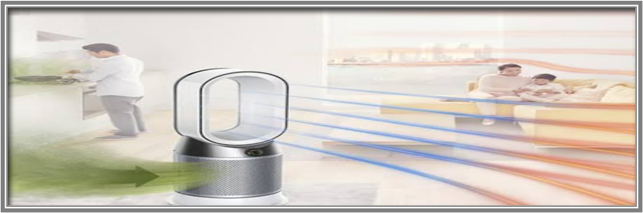We have to make a model of air purifier with hard cardboard ,and make a square shape . And we want two different types of car filter (one is cylindrical and other one is rectangular). A on and off switch, exhaust fan .By installing the cylindrical car filter in the middle and connecting to the exhaust fan and then connecting to a USB cable so . By connecting all the current connections to the on and off switch and installing the rectangular air filter at the opening of square cardboard the air purifier is will be ready to work

. 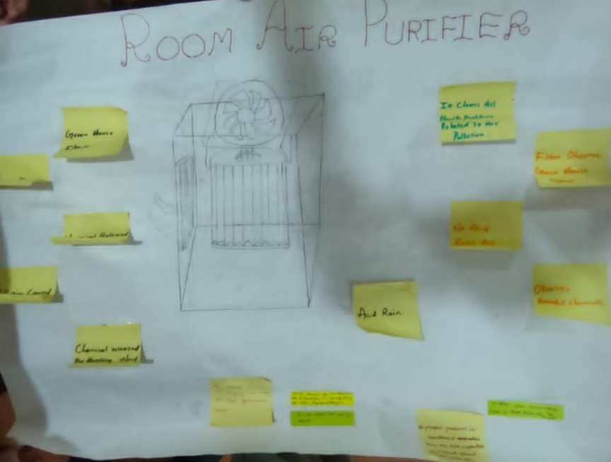

The air pollution monitoring device developed in our project is based Arduino UNO. The Arduino board connects with ThingSpeak platform using ESP8266 Wi-Fi Module. As the cities usually have Wi-Fi hotspots at most of the places, so the device can be easily installed near any hotspot for its operation . The ThingSpeak is a popular IOT platform which is easy to use and program.  The sensor used for monitoring the air pollution is MQ-135 gas sensor. The sensor data is also displayed on a character LCD interfaced in the monitoring device.

**FLOW CHART :**

START

Include LiquidCrystal Library and define

the pins on arduino to

which

MQ135 data pins are connected.

int airquality=0

Start accepting data from sensor and sending

data to 16x2 LCD.

“Air quality” value is read

from analog pin of arduino to which MQ135

is connected.

The cursor of the LCD is set to line 0 and

column 0, and in that line the Air quality

is displayed.

There is a delay of 100 microseconds and then the values are read from sensor again.

END

**5.Prototype**

The next step is making a prototype , that is for making a prototype we require components like

**COMPONENTS REQUIREMENTS :-**

1) Air filter.

2)Cooling fan.

3) Usb adaptor .

4) Switch .

5) Arduino UNO.

6) Mq135 sensor.

7) Breadboard .

8)16*2 lcd display.

9 Potentiometer.

**TOTAL COST OF OUR PROJECT IS =Rs 2500\-**

WHEREAS THE COST OF THE AIR PURIFIER IN THE MARKET ARE APPROXIMATELY AROUND 6000 TO 7000 RUPEES BY OUR PROJECT WE CAN REDUCE THE COST OF THE AIR PURIFIERS .AND ALSO PROVIDE A AIR QUALITY MONITORING DEVICE WITH A AIR PURIFIER .

**(i) CAR FILTER:-**

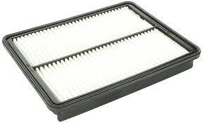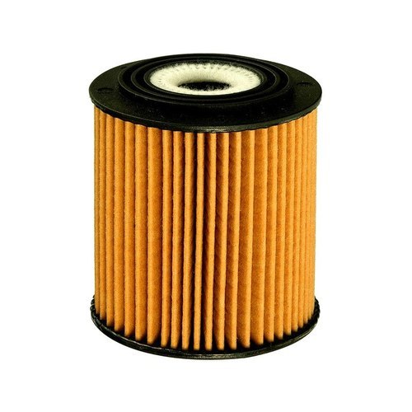The cabin filter allows you to breathe clean air, by filtering bacteria, pollen and polluting substances. Whether or not you’re using the air conditioner, the [cabin air filter](https://auto.howstuffworks.com/under-the-hood/vehicle-maintenance/change-cabin-air-filter.htm) keeps dust, pollen and other air pollutants out of the air you breathe while driving. The cabin air filter is part of the ventilation system. This rectangular screen keeps a number of things out of the air inside the car.

(ii)  **COOLING FANS IN COMPUTERS :-**

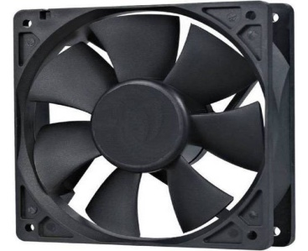A **computer fan** is any fan  inside, or attached to, a computer case is used for active cooling. Fans are used to draw cooler air into the case from the outside, expel warm air from inside and move air across a heat sink to cool a particular component.

(iii)  **USB CABLE :-**

* The term USB stands for **"Universal Serial Bus"**.  USB cable assemblies are some of the most popular cable types available, **used mostly to connect computers to peripheral devices** such as cameras, camcorders, printers, scanners, and more.USB cables carry power as well as signals.  This allows for "USB powered" gadgets as well as recharging batteries in cameras and other USB peripherals
* 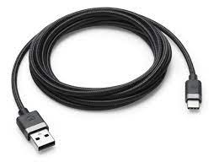USB cables are designed with several distinct connector types, making it easy to identify which plug goes into the computer and which plug goes into the peripheral device

**(iv) ON AND OFF SWITCH:-**

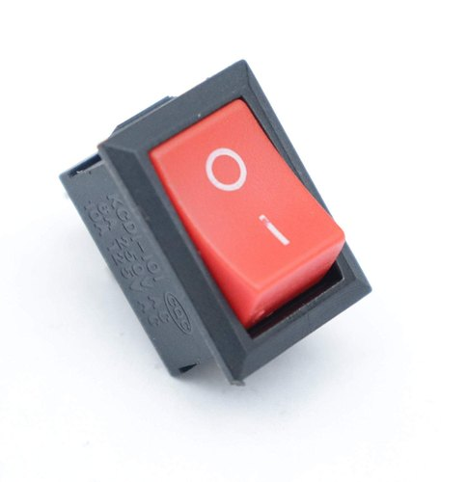The well-known on/off power symbol was the result of the logical evolution in user interface design. Originally, most early power controls consisted of switches that were toggled between two states demarcated by the words On and Off. As technology became more ubiquitous, these English words were replaced with the universal symbols line "|" and circle "o" to bypass language barriers. This standard is still used on toggle power switches.

The symbol for the standby button was created by superimposing the symbols "|" and "o"; however, it is commonly interpreted as the numerals "0" and "1". Yet the

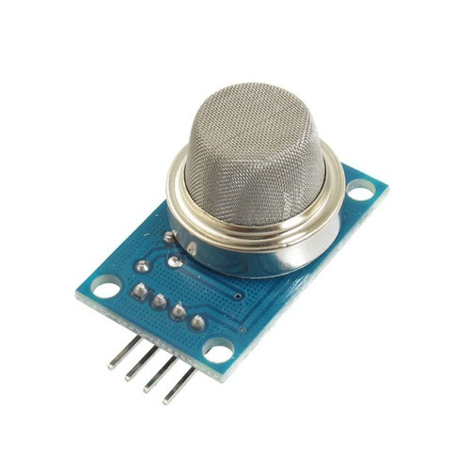**(V) MQ-135 SENSOR:-**

Air Quality Sensor (MQ135):- Product Description: Air quality click is suitable for detecting ammonia (NH3), nitrogen oxides (NOx) benzene, smoke, CO2 and other harmful or poisonous gases that impact air quality. The MQ-135 sensor unit has a sensor layer made of tin dioxide (SnO2), an inorganic compound which has lower conductivity in clean air than when polluting gases are present. To calibrate Air quality, use the on-board potentiometer to adjust the load resistance on the sensor circuit.

**Pin Description**:

* 1, the VDD power supply 5V DC
* 2,GND , used to connect the module to system ground
* 3, DIGITAL OUT, You can also use this sensor to get digital output from this pin, by setting a threshold value using the potentiometer
* 4, ANALOG OUT, This pin outputs 0-5V analog voltage based on the intensity of the gas.

**(VI) 16X2 LCD Panel:-**

**Product Description:**

A liquid-crystal display (LCD) is a flat-panel display or other electronically modulated optical device that uses the light-modulating properties of liquid crystals. Liquid crystals do not emit light directly, instead using a backlight or reflector to produce images in color or monochrome. [1] LCDs are available to display arbitrary images (as in a general-purpose computer display) or fixed images with low information content, which can be displayed or hidden, such as preset words, digits, and seven-segment displays.

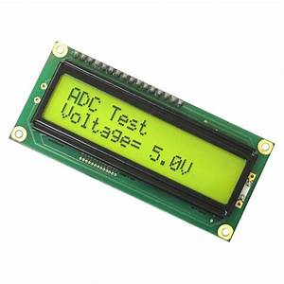

**(VII) Potentiometer:-**

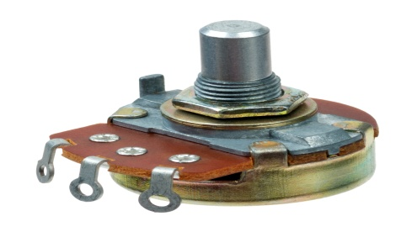 A potentiometer is a three-terminal resistor with a sliding or rotating contact that forms an adjustable voltage divider. If only two terminals are used, one end and the wiper, it acts as a variable resistor or rheostat. The measuring instrument called a potentiometer is essentially a voltage divider used for measuring electric potential (voltage); the component is an implementation of the same principle, hence its name.

**(VIII) Arduino Uno:-**

**Product Description:** Arduino is an open source computer hardware and software company, project, and user community that designs and manufactures single-board microcontrollers and microcontroller kits for building digital devices and interactive objects that can sense and control objects in the physical world. The boards are equipped with sets of digital and analog input/output (I/O) pins that may be interfaced to various expansion boards (shields) and other circuits. The boards feature serial communications interfaces, including Universal Serial Bus (USB) on some models.

The microcontrollers are typically programmed using a dialect of features from the programming languages C and C++.

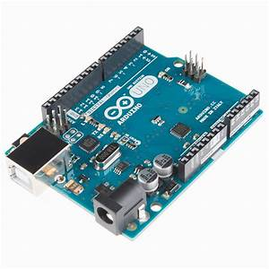

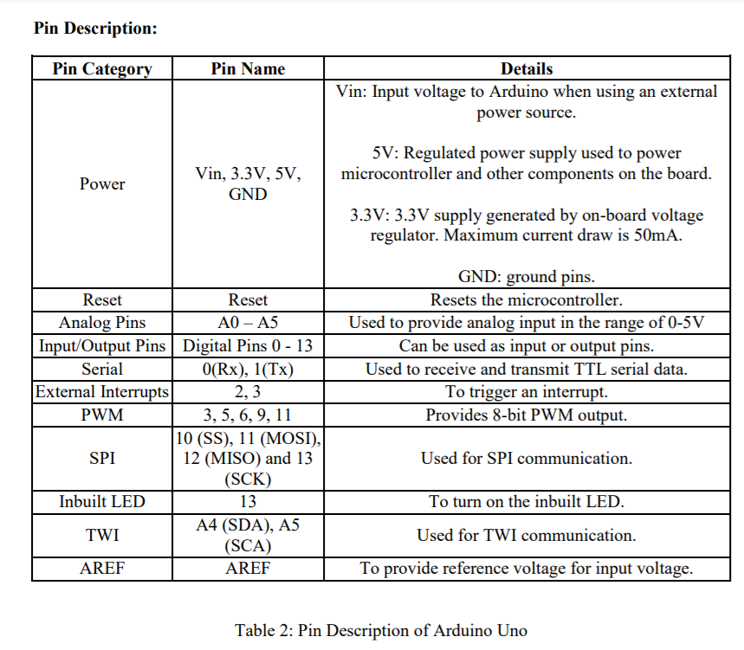

**Prototype Model:**

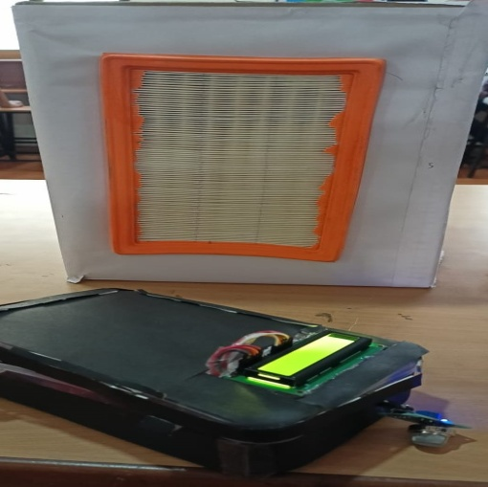

**SOURCE CODE**

//Program to

#include <SoftwareSerial.h>

#include <LiquidCrystal.h>

LiquidCrystal lcd( 12, 11, 5, 4, 3,2);

float t=0;

char data = 0;

// replace with your channel's thingspeak API key

String apiKey = "8NBNB4VQ9F2EEWQM";

// connect 0 to TX of Serial USB

// connect 1 to RX of serial USB

SoftwareSerial ser(0,1); // RX, TX

// this runs once

void setup()

{

ser.begin(9600);

lcd.begin(16, 2);

lcd.setCursor(0,0);

lcd.print("EEP PROJECT");

lcd.setCursor(0,1);

delay(3000);

lcd.clear();

lcd.setCursor(0,0);

lcd.print(" IOT AIR");

lcd.setCursor(0,1);

lcd.print("QUALITY MONITOR");

ser.println("AT+GMR");

delay(1000);

ser.println("AT+CWMODE=3");

delay(1000);

ser.println("AT+RST");

delay(5000);

ser.println("AT+CIPMUX=1");

delay(1000);

String cmd="AT+CWJAP=\"Wifi Ssid\",\"Password\"";

ser.println(cmd);

delay(1000);

ser.println("AT+CIFSR");

delay(1000);

lcd.clear();

lcd.setCursor(0,0);

lcd.setCursor(0,1);

lcd.print(" CONNECTED");

}

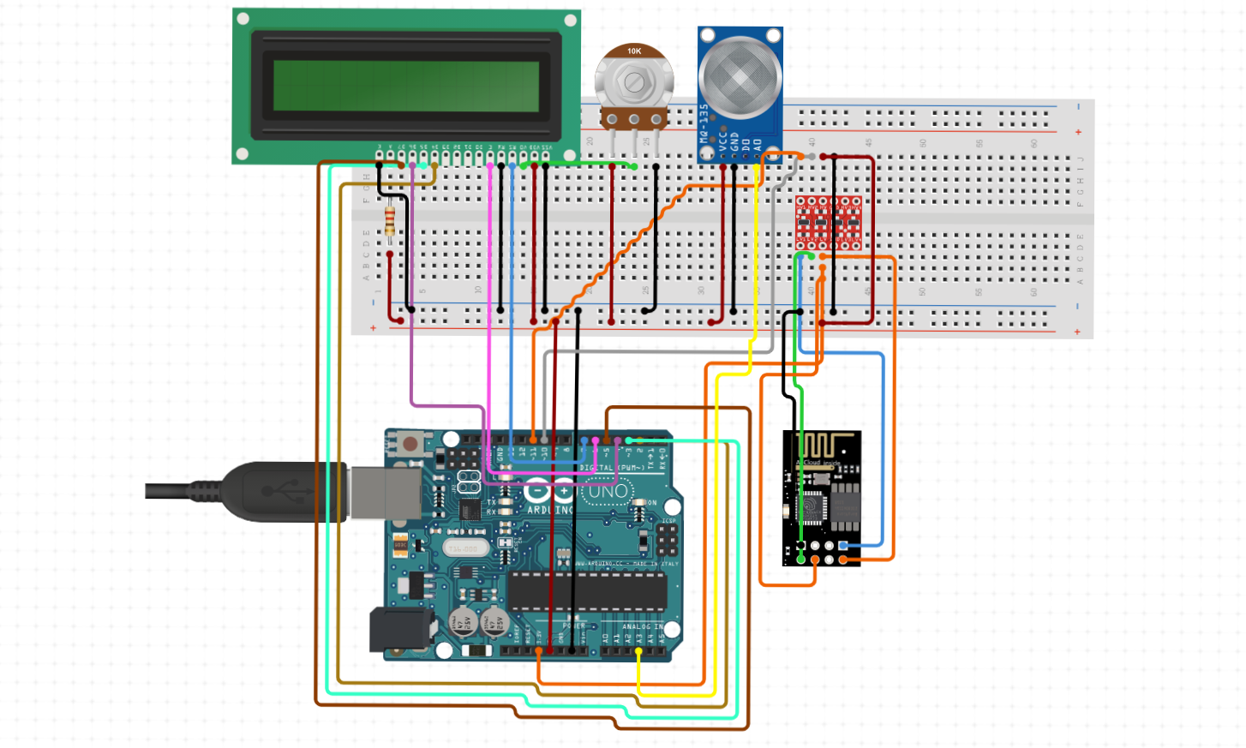

**CIRCUIT DIAGRAM:**

**6.Test**

we have also found errors in uploading the code to the arduino that it is showing compile error. we didn't include the library files to code.so, we installed the libraray file named <servo.h> in the ardunio software .Then code complied succesfully and done uploading.

Testing the setup ‘n’ number of times will make us to clear all the loop holes which are in it . And the final product efficient and its performance is be good and considerable and other working models.

And while uploading the code make sure you are connected to the port and upload it using the rightarrow.

By our innovation in our project, we can reduce the pollutants in the air and the diseases causing due to air pollution . To make a air purifier which can be affordable to everyone and has low maintenance. we have learnt much from this topic or project which we took up. We have introduced the design and implementation of a low cost air purifier with pollution monitoring device . This air purifier along with the monitoring device can be easily manufactured on a large scale for mass production because of its simplicity and ease of design. And we hope this will help the society for over coming problems like air pollution.

we have tested several times that the exhaust fan pulls the air inside and passes through the bike filter and air was strucked inside the air filter to over come these problems we have used another exhaust fan to pull the air from the filter and passes through the car filter with pressure and comes out. hence un-purified air is converted into purified air.

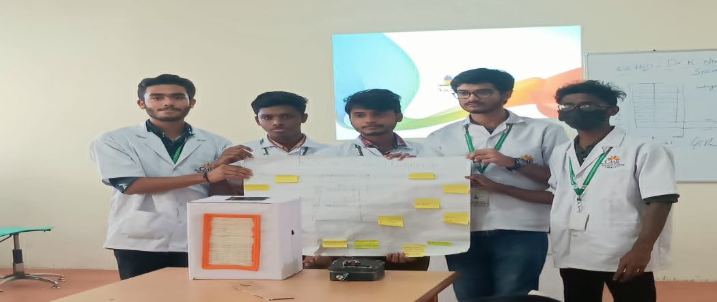

**REFERENCES:-**

* *https://en.wikipedia.org/wiki/Arduino#/media/File:UnoConnections.jpg*
* [*http://www.circuitbasics.com/how-to-set-up-the-dht11-humidity-sensor-on-an-arduino/*](http://www.circuitbasics.com/how-to-set-up-the-dht11-humidity-sensor-on-an-arduino/)
* [*https://playground.arduino.cc/Main/DHT11Lib*](https://playground.arduino.cc/Main/DHT11Lib)
* [*https://www.robot-r-us.com/vmchk/sensor-temp/humid/dht11-temperature-and-humiditysensor.html*](https://www.robot-r-us.com/vmchk/sensor-temp/humid/dht11-temperature-and-humiditysensor.html)
* [*https://electrosome.com/power-supply-design-5v-7805-voltage-regulator/*](https://electrosome.com/power-supply-design-5v-7805-voltage-regulator/)
* [*https://www.epa.gov/air-research/air-monitoring-measuring-and-emissions-research*](https://www.epa.gov/air-research/air-monitoring-measuring-and-emissions-research)
* [*http://howtomechatronics.com/tutorials/arduino/dht11-dht22-sensors-temperature-and-humiditytutorial-using-arduino/*](http://howtomechatronics.com/tutorials/arduino/dht11-dht22-sensors-temperature-and-humiditytutorial-using-arduino/)
* [*https://www.elprocus.com/ever-wondered-lcd-works/*](https://www.elprocus.com/ever-wondered-lcd-works/)
* [*https://www.google.co.in/search?q=dht11&client=firefox-a&rls=org.mozilla:enUS:official&channel=np&dcr=0&source=lnms&tbm=isch&sa=X&ved=0ahUKEwj8sMu0oPXAhUlTY8KHW8wB6kQ_AUICigB&biw=1366&bih=598*](https://www.google.co.in/search?q=dht11&client=firefox-a&rls=org.mozilla:enUS:official&channel=np&dcr=0&source=lnms&tbm=isch&sa=X&ved=0ahUKEwj8sMu0oPXAhUlTY8KHW8wB6kQ_AUICigB&biw=1366&bih=598) *.*